Experiment Number : 11 Date:
Implementation of multiple inheritance in Java using Interface

Aim:
Write a Java program to implement multiple inheritance using Interface.

PRE LAB EXERCISE
QUESTIONS
- Why does Java not support multiple inheritance using classes like that of C?
Java avoids multiple inheritance with classes to prevent the Diamond Problem, where ambiguity occurs if two parent classes define the same method. Java uses interfaces instead, ensuring clearer and safer inheritance.

- What is the primary purpose of an interface in Java?
- To define a contract of methods a class must implement
An interface specifies method declarations without implementations. Any class implementing the interface must provide definitions for those methods, ensuring consistent behavior across different classes.

IN LAB EXERCISE
Objective
To demonstrate how an interface in Java defines constants and abstract methods, which are implemented by a class.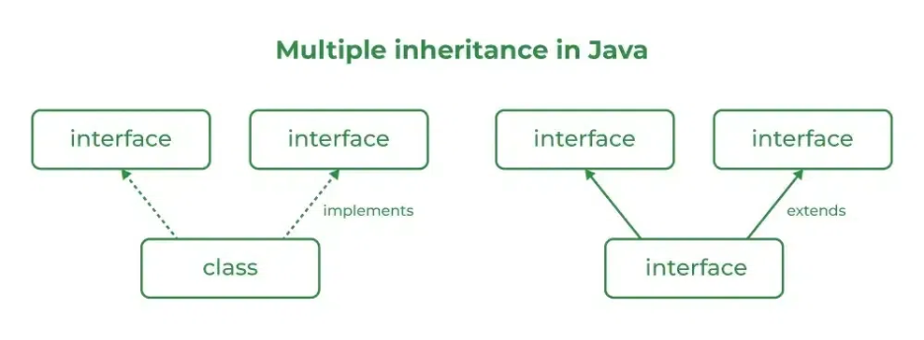

Source Code
import java.io.*;
// Add interface
interface Add{
int add(int a,int b);
}
// Sub interface
interface Sub{
int sub(int a,int b);
}
// Calculator class implementing Add and Sub
class Cal implements Add , Sub
{
// Method to add two numbers
public int add(int a,int b){
return a+b;
}
// Method to sub two numbers
public int sub(int a,int b){
return a-b;
}
}
Public class Example{
// Main Method
public static void main (String[] args){

// instance of Cal class
Cal x = new Cal();
System.out.println("Addition : " + x.add(2,1));
System.out.println("Subtraction : " + x.sub(2,1));
}
}

Outputs
Addition : 3
Subtraction : 1

POST LAB EXERCISE
  - Can a functional interface extend another interface?
Yes, a functional interface can extend another interface, provided the resulting interface still has only one abstract method. If multiple abstract methods exist after extension, it will no longer qualify as functional.

  - Which feature was introduced in interfaces starting from Java 8?
Default and static methods.
Java 8 introduced default methods and static methods in interfaces. Default methods allow method implementation inside interfaces, enabling backward compatibility when new methods are added.

ASSESSMENT

Description | Max Marks | Marks Awarded
Pre Lab Exercise | 5
In Lab Exercise | 10
Post Lab Exercise | 5
Viva | 10
Total | 30
Faculty Signature

